MZUZU DIOCESE
2016 MALAWI SCHOOL CERTIFICATE OF EDUCATION
BIOLOGY
Subject Number: M022/1
Tuesday, 15 March Time Allowed: 2hr.30min
7:30 – 10:00am
PAPER I
(100 marks)

Instructions

Question Number | Tick if answered | Do not write in these columns
1
2
3
4
5
6
7
8
9
10
11
12
13
14
1. This paper contains 14 pages. Please check.
2. Before beginning write your name at the top
of the question paper and on all other sheets.

3. This paper contains sections A, B and C.
Answer all questions in all the sections. Some
can be answered quickly, but others require
considerable thought and may take longer.

4. Write your answers on the question paper in
the spaces provided. The maximum number of
marks for each answer is indicated against
each question

5. In the table provided on this page, tick against
the question number you have answered.

© 2016 MZUZU DIOCESE Turn Over
SectionA (20 marks)
Answer all questions in this section
- a.State one function of the following cell organelles.
- Smooth endoplasmic reticulum
_____________________________________________________________________________________________________________ (1 mark)
- Ribosomes
_____________________________________________________________________________________________________________ (1 mark)

  - Figure 1show a physiological process which occurs in living cells. Use it to answer questions that follow.

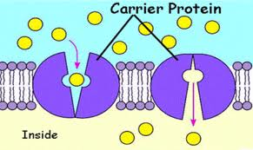
Figure 1

- Identify the process in the figure.
________________________________________________ (1 mark)
- Name the organelle whose presence is very important for the occurrence of the process.
________________________________________________ (1 mark)
- Give a reason to your answer in question a (ii).
______________________________________________________________________________________________________(2 marks)

2 a. Suggest any two ways by which a baby may contract HIV from her pregnant
mother.

_____________________________________________________________
______________________________________________________ (2 marks)

  - Apart from avoiding infections, state twoother ways how a pregnant mother can help her baby develop healthily.
__________________________________________________________________________________________________________________ (2 marks)

3. Figure 2 below shows a magnified inner surface of small intestines. Use it to answer questions that follow.
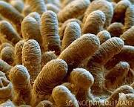
Figure 2

- (i)Identify the structures in the figure.
___________________________________________________ (1 mark)
- What is the function of the structures in the digestive system?
______________________________________________________________________________________________________________ (1 mark)
- Statetwoways inwhich the structures are adapted for the function stated in (ii).
______________________________________________________________________________________________________________ (2 marks)
  - Name the fluid which transports products of digestion of lipids from the smallintestines.
______________________________________________________ (1 mark)
4. Figure 3 shows a reflex arc which results in the lower leg being kicked forward. Study it to answer questions that follow.
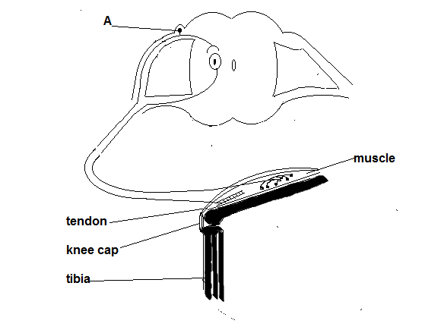

Figure 3

  - (i) Name the reflex action shown.
______________________________________________________ (1 mark)
(ii) In the figure draw two arrows to show the direction of nerve impulse.
(1 mark)
  - Describe the pathway of the reflex action named in a(i) above.
_____________________________________________________________________________________________________________________________________________________________________________________________________________________________________________(3marks)

Section B (60 Marks)
5. Figure 4 shows the carbon cycle in an ecosystem.
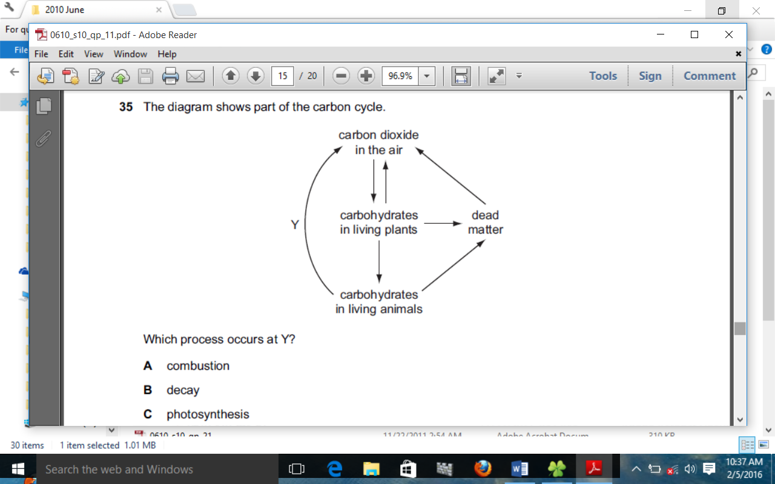.
Figure 4
a. (i) Name the process taking place at Y.
_____ _________________________________________________ (1 mark)
- What process releases carbon dioxide from the dead matter?
_____ _________________________________________________ (1 mark)
- What is the collective name for the organisms that release carbon dioxide from dead matter?
______________________________________________________ (1 mark)
- Mention any two human activities which contribute to an accumulation of carbon dioxide in the atmosphere.
i_______________________________________________________________ ii______________________________________________________ (2 marks)

- Explain how these activities have contributed to climate change.
________________________________________________________________________________________________________________________________________________________________________________________ (2 marks)

- The following chemical equations represent the two types of a chemical reaction that takes place in tissues of organisms. Study them and answer questions that follow.
Reaction A: C₆H₁₂O₆+ O₂6CO₂ + 6H₂O + 2898KJ
Reaction B: C₆H₁₂O₆ lactic acid + 210KJ
- Explain why more energy is produced in reaction A than in B.
_______________________________________________________________________________________________________________________________________________________________________________ (2 marks)
- Describe the situation that usually causes the reaction B to occur in human instead of reaction A.
_______________________________________________________________________________________________________________________________________________________________________________ (2 marks)
- Apart from energy, what would be the other products if reaction B occurred in plants?_______________________________________________________________________________________________________________________________________________________________________________( 2 marks)

- Figure 5is a diagram of a cross section through the human heart.
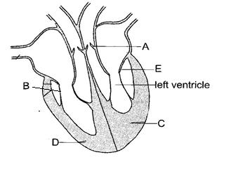
Figure 5
- During systolic pressure, what happens to the parts marked A and C?
- ________________________________________________ (1 mark)
- ________________________________________________ (1 mark)
- What happens to the contents of the ventricles during systole?
_____________________________________________________ (1 mark)
- Name the part marked E. _____________________________________________________ (1 mark)
- Explain what would happen if part marked B was damaged? __________________________________________________________________________________________________________________ (2 mark)

- Figure 6 below shows two structures of nephrons of different animals living in different environments. Use it to answer question that follow
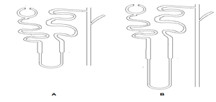
Figure 6

a. (i)Which animal lives in desert environment?
____________________________________________________1 mark

(ii) Give a reason for your answer to a (i).
______________________________________________________________________________________________________________________________________________________________________________ 2 marks
  - Explain the role of pituitary gland when there is high concentration of salts in the human blood.
__________________________________________________________________________________________________________________________________________________________________________________________________________________________________________________________________________________________________________4 marks

- Figure7 is a diagram showing two pure lines of peas that Gregor Mendel cross pollinated in his experiments on heredity. Use it to answer the question that follow.
Round seed wrinkled seed
x

Figure 7
  - (i)What is meant by ‘pure line peas’?
________________________________________________ (1 mark)

- Which of the two pure lines has a recessive characteristic?
_________________________________________________ (1 mark)

- Give a reason for your answer to a (ii) above.
___________________________________________________ (1 mark)

  - When the F₁ seeds are selfed, 25% of the F₂ seeds are wrinkled.
(i)What is meant by ‘selfing F₁’?
___________________________________________________ (1 mark)
(ii) Using the symbol ‘R’ for a dominant allele and ‘r’ for a recessive allele,
draw a well labeled punnet square to show how the wrinkled seeds were
produced.

4 marks
- Figure 8 below shows the structure of a feather as observed under a microscope. Use it to answer questions that follow.
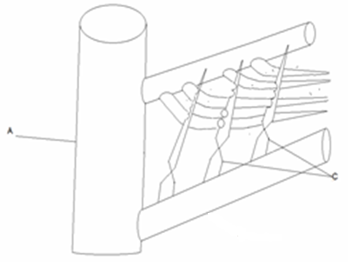
Figure 8

a. Name parts labeled
- ________________________________________________ (1 mark)
- ________________________________________________ (1 mark)
b. (i) Name the type of feather above.
_________________________________________________ (1 mark)
- Give a reason for your answer.
________________________________________________________________________________________________________ (2 marks)
- a. Write down two effects of cancerous cells.
________________________________________________________________________________________________________________________________________________________________________________________ (2marks)

  - Describe how an individual could acquire the following
(i) Natural active immunity.
_______________________________________________________________________________________________________________________________________________________________________________(2 marks)
(ii) Artificial active immunity.
_______________________________________________________________________________________________________________________________________________________________________________ (2 marks)

c. State the importance of immunization on an individual.
________________________________________________________________________________________________________________________________________________________________________________ (1 mark)

- a. Explain how population age structure affects human population growth.
_____________________________________________________________
_____________________________________________________________
_____________________________________________________ (2 marks)
  - Discuss how rapid population growth accelerates pollution of the environment.
_______________________________________________________________________________________________________________________________________________________________________________ (2 marks)

- In a natural population there are variations amongst individual organisms and the number of organisms born greatly exceeds the number that survives to reproductive stage.

  - Name two factors which contribute to a reduction in the number of organisms that survive to reproductive stage.
__________________________________________________________________________________________________________________ (2 marks)

  - How does a reduction in number help in bringing about evolutionary change?
__________________________________________________________________________________________________________________ (2 marks)

  - Explain the role played by a changing environment in the evolution of species.
_______________________________________________________________________________________________________________________________________________________________________________ (2 marks)

- A student set up an experiment as shown in the figure 9 below. Use it to answer questions that follow.
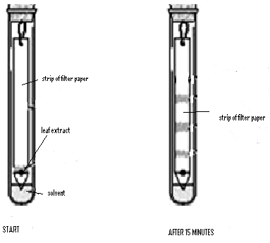
Figure 9
  - What was the aim of this experiment?
___________________________________________________________________________________________________________________ (1 mark)

  - Name the experimental procedure in the figure.
______________________________________________________ (1 mark)

- Draw the conclusion of the experiment basing on what was observed after 15 minutes. ____________________________________________________________________________________________________________________________________________________________________________________________________________________________________________(2 marks)
Section C (20 Marks)
Answer all questions in this section

- Discuss how proteins in a beef meal would eventually become deaminated as amino acids in the body. Your answer should be in an essay form. _______________________________________________________________________________________________________________________________________________________________________________________________________________________________________________________________________________________________________________________________________________________________________________________________________________________________________________________________________________________________________________________________________________________________________________________________________________________________________________________________________________________________________________________________________________________________________________________________________________________________________________________________________________________________________________________________________________________________________________________________________________________________________________________________________________________________________________________________________________________________________________________________________________________________________________________________________________________________________________________________________________________________________________________________________________________________________________________________________________________________________________________________________________________________________________________________________________________________________________________________________________________________________________________________________________________________________________________________________________________________________________________________________________________________________________________ (10 marks)
16. Describe a controlled experiment which can be carried out to show the effect of
unequal distribution of gravity on a plant root. ___________________________________________________________________________________________________________________________________________________________________________________________________________________________________________________________________________________________________________________________________________________________________________________________________________________________________________________________________________________________________________________________________________________________________________________________________________________________________________________________________________________________________________________________________________________________________________________________________________________________________________________________________________________________________________________________________________________________________________________________________________________________________________________________________________________________________________________________________________________________________________________________________________________________________________________________________________________________________________________________________________________________________________________________________________________________________________________________________________________________________________________________________________________________________________________________________________________________________________________________________________________________________________________________________________________________________________________________________________________________________________________________________________________________________________________________________________________________________________________________________________________________________________________ (10 marks)
END OF QUESTION PAPER

